**COVID-19 Authorization Letter**

03/02/2021

To whom it may concern

The One Click Solutions Management hereby gives **Jane Doe – JANDOE001** permission to visit the offices.

Reason: For maintenance

Contact: 0827658282

Duration: Until 31/07/2021

Yours Sincerely,

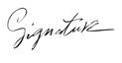

Ammar Canani

CEO One Click Solutions